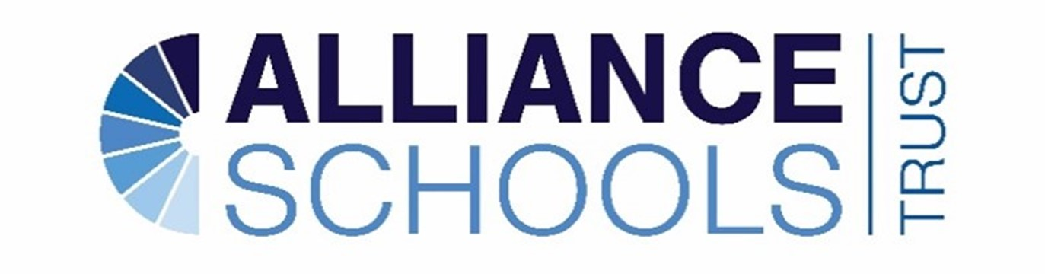
The Alliance Schools Trust Improvement Strategy (SIS)
Mission – Delivering for our children, staff and communities through collaboration, partnership and innovation:
An inclusive, ambitious & successful EDUCATION
A culture of CARE, loyalty & empathy
Inspiring & memorable learning OPPORTUNITIES

Vision – The Alliance Schools Trust unites the collective strengths of its schools to deliver exceptional Education, Care & Opportunity for everyone within its learning community. Through meaningful collaboration and partnership, each school retains its distinctive character while working as true allies – celebrating diversity, empowering lives and driving ambition and achievements for all.

SIS Aim - To seek and achieve academic and personal success for all children across the Trust. To do this the Trust will understand the needs of every school and see this as an essential ingredient for delivering impact.

As a group of schools, we want to achieve the following:

- A knowledge rich and ambitious curriculum leading to vibrant learning.
- Social mobility leading to higher/vocational learning or apprenticeships.
- Evolution of self through character development for all children.
- Growth of great leaders, subject specialists and supportive associate staff who know our schools well.
- Be the Trust of choice where we celebrate our collective achievements because we bring our best selves to our schools each day.

The SIS is closely connected to the following:
Trust Development Plan, School Development Plans, Trust Self Evaluation, School Self Evaluations
Scheme of Delegation, Workforce Development Plan

The Cycle of Improvement: ‘Keep it simple and execute it brilliantly!’
Hold our values of Care – Education – Opportunity at the core of everything we do.

Diagnosis of Need – prioritisation – action plan – capacity to address the plan – Delivery of the plan – Evaluation of the work – remove the additional support if secure.
This isn’t complex and is based on evidence from Sir David Carter (Ex-National School Commissioner)

Identification for Improvements:
The following information will support decision making:
- External school improvement partner reports, learning walks, financial strength of each school, self-evaluations, academic outcomes and future data, questionnaire feedback from all stakeholders, Ofsted reports.

Key Personnel involved with SIS:
Identification via:
- Senior Teams ongoing monitoring, independent SIP reviews, CEO reviews and line management of HT’s, external academic data, external reports e.g. Ofsted.

Support/Capacity to address the issue:
- Collaboration through peer reviews across our schools.
- Collaboration through peer reviews across local trusts.
- Subject leader/Phase leader conversations across our schools.
- CPD with shared themed events.
- Coaching and mentoring programme across our schools.

Evaluation via:
- Academic outcomes, learning walks, feedback from stakeholders.

